

MARLBOROUGH TOWN COUNCIL

JOIN US AS A TOWN COUNCILLOR

Co-option Process
If you would like to make a difference, have a chance to change things and represent your community, why not consider becoming a Town Councillor? A vacancy has arisen for a Councillor to represent Marlborough’s West Ward and the Town Council can now co-opt someone to this position.

Interested? Here is the information:

Do I qualify?
Firstly, you will just need to confirm that you qualify. So, this means you need to be:

A British, Commonwealth or European Union citizen 18 years old or over
and meet at least one of the following four qualifications

- your name is on the electoral register for the parish, or
- during the previous 12 months have owned or tenanted land or premises in the parish, or
- during the previous 12 months your principal or only place of work has been in the parish, or
- during the previous 12 months you have resided in the parish or within 3 miles of it.

Certain people are unable to stand and these include paid officers of the council, those subject to bankruptcy orders and those subject to recent sentences of imprisonment. (More details are set out on the co-option form)

What is the next step?
Complete a co-option form confirming that you qualify and let us have a written statement (no more than one side of A4) setting out why you would like to serve as a Councillor and what attributes you could bring to the role.

This statement will be included in agenda papers for an Extraordinary Full Town Council meeting on Wednesday 29 March when our Councillors will select (co-opt) a new Councillor. The deadline for letting us have confirmation that you qualify and your written statement is 4pm on Friday 17 March 2023.

How will candidates be selected?
At the meeting itself and as part of the agenda, you will be asked to make a short presentation (no more than 3-5 minutes) after which Town Councillors will ask you questions.

After Councillors have seen all candidates, they will vote for their preferred one. You will be informed of the outcome immediately afterwards or as soon as possible the following day.

Is there anything else I need to know?
Please feel free to contact Richard Spencer-Williams, the Town Clerk, to arrange a chat about the Town Council and its committees and the role of a Town Councillor. It’s worth having a look at our website at www.marlborough-tc.gov.uk and having a browse through previous minutes too.

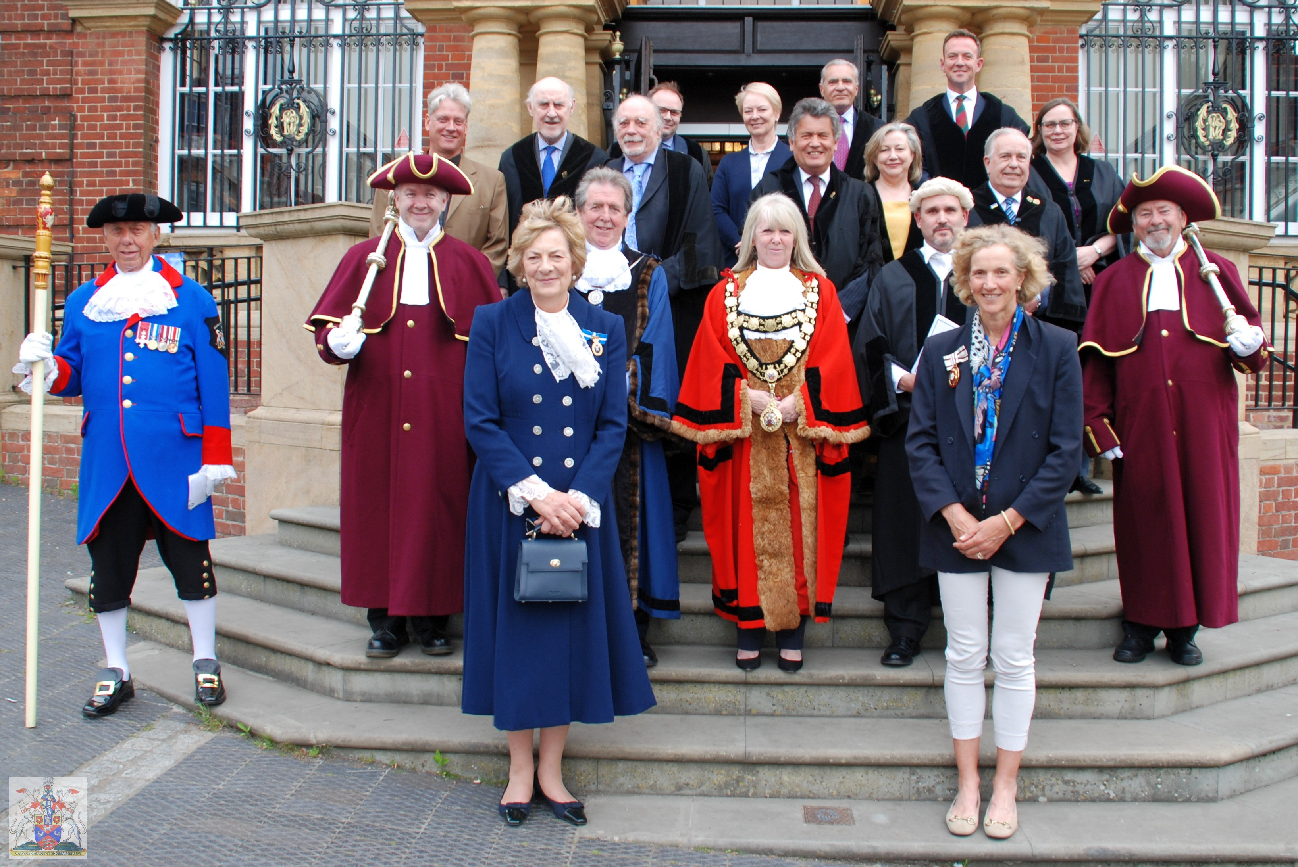
Councillor Lisa Farrell, Town Mayor, and Marlborough Town Councillors look forward to meeting you

Looking forward to hearing from you!

March 2023



Co-option Eligibility Form

- To be eligible for co-option as a Marlborough Town Councillor you must be a British citizen, or a citizen of the Commonwealth or the European Union; 18 years of age or over and able to meet at least one of the following qualifications set out below. Please mark as appropriate -

I am registered as a local government elector for the parish of Marlborough; or
I have, during the whole of the twelve months preceding the date of the co-option, occupied as owner or tenant, land or other premises in the parish; or
My principal or only place of work during those twelve months has been in the parish; or I have during the whole of twelve months lived in the parish or within 3 miles of it

- There are some people who are disqualified from being a Councillor. You cannot become a Councillor if –

  - You are employed by the parish/town council
  - You are the subject of a bankruptcy restrictions order or interim order
  - You have been sentenced to a term of imprisonment for three months or more (including a suspended sentence), without the option of a fine, during the previous five years
  - You have been disqualified under the Representation of the People Act 1983 (which covers corrupt or illegal electoral practices and offences relating to donations).

I (insert name) confirm that I am eligible to apply for the vacancy of
Marlborough Town Councillor and the information given on this form is a true and accurate record.

Signed ……………………………………………………… Dated ………………………….

PTO

Please add your contact details so we can get in touch.

By phone

By email

Postal address

Return your form to arrive before 4pm on Friday 17 March 2023 to: townclerk@marlborough-tc.gov.uk
or

Marked ‘Private and Confidential’ by post to Mr Richard Spencer-Williams, Town Clerk, Marlborough Town Council, 5 High Street, Marlborough SN8 1AA

